DNR Degree college(W) palakol
Department of English
William Shakespeare birthday celebrations
Date:22-04-2022

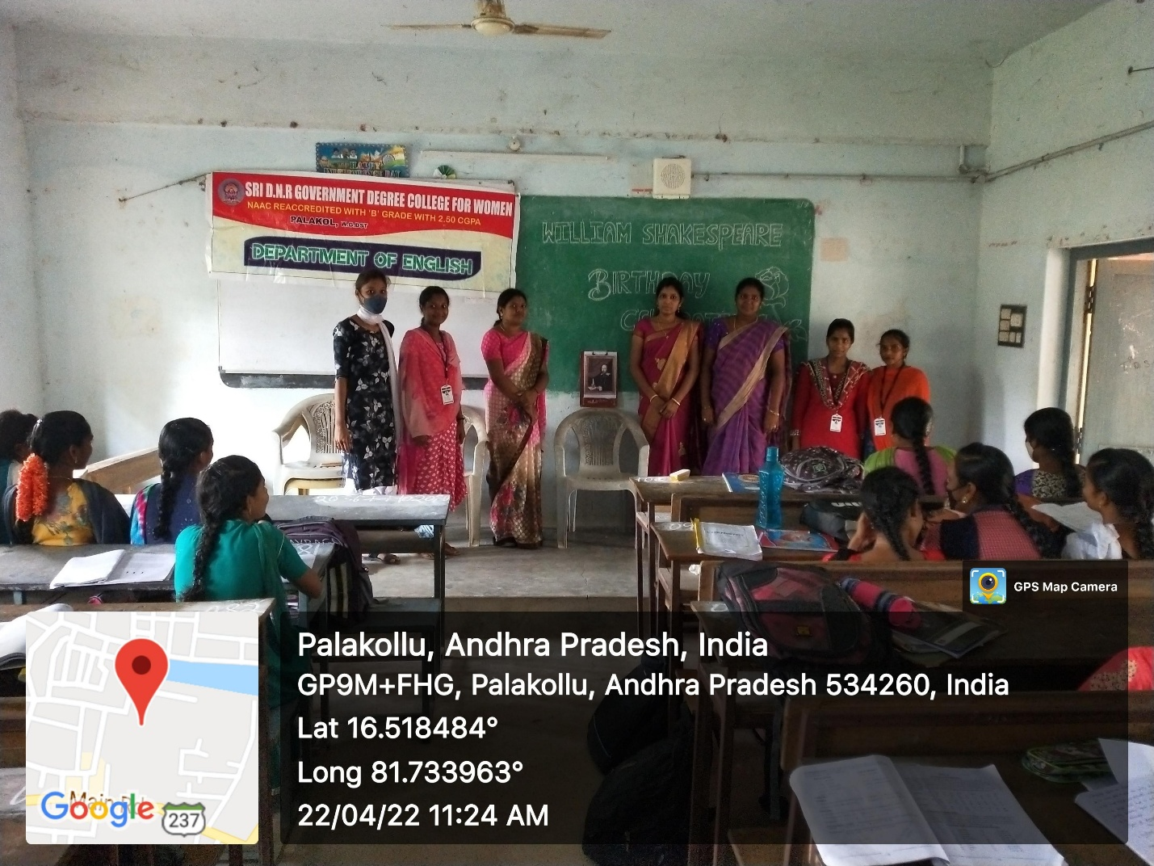
Objective: To remember the Father of the modern English literature “William Shakespeare” and to motivate every student by his poetry,dramas . Students will know more about Shakespeare and about his poems,dramas,and short stories.
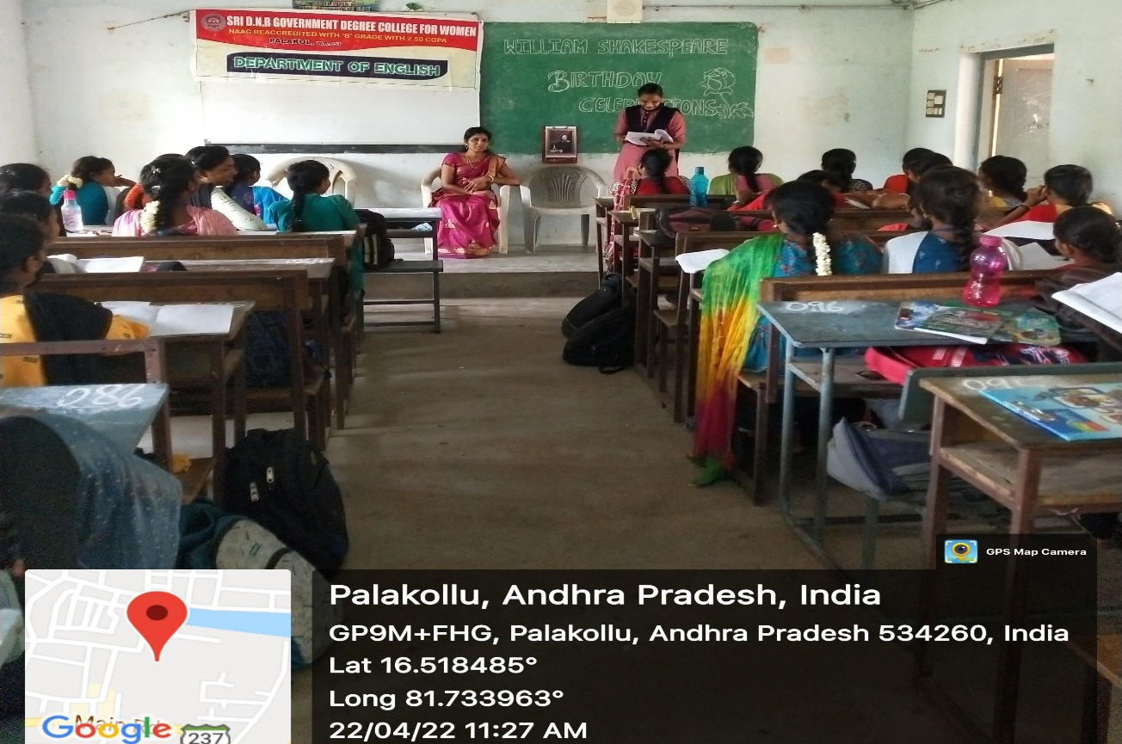
Description: On the birthday of William Shakespeare 1st BSC (MPC,MPCS,CBZ) students nearly 80 members have participated .Some students gave paper presentation on Shakespeare poems.Two members talked about his famous drama Hamlet.
Outcome: By the end of the programme students came to know about William Shakespeare’s poems and Dramas.And they have motivated by his poems.They showed very much interest while listening to the drama Hamlet .

